IMAT2207 Agile Team Development
Practical – Unit 3

Connecting to SQL Server
Configuring the database

Linking to the Database 1
Before you Begin 1
SQL Server Team Database 1
How this will work – Copy and Adapt 1
Creating your Account 2
Creating your Database 2
Managing your Database 3
Accessing the Database in Visual Studio 3
Creating Tables 5
Assigning Primary Keys 6
Adding Data to the Table 10
Creating Stored Procedures 10
Testing the Stored Procedure 12
Setting up a Local Database 13
Creating the Folder Structure for your Database 13
Generating the Connection String 18

Linking to the Database

Before you Begin
Make sure that you have completed the work for last week and that you have watched the eLectures for this week before starting this work.

SQL Server Team Database
As a student you have access to a free SQL Server account.
One person in your team will create the team database and will be the database account holder. It is on their p number that the database needs to be created. All team members will then create their own table within the team database once the database account holder has distributed the username and password to each of the team members.
Working as a team, SQL Server provides the big advantage that each team member may connect to and use the database simultaneously. In other alternative configurations there is the risk of having multiple copies of the same data (one database for each team member) along with the risk of locking all members out of the system while one person is editing the schema.
Currently the SQL server database is only available within the DMU campus if you wish to access the database off campus then each member must run their work using the My DMU Lab URL:
https://yourdmulabs.dmu.ac.uk
Note that there is also an option for setting up a local database. The instructions on how to do this are at the end of this document but note that it is not possible to share a local database with the members of your team.

How this will work – Copy and Adapt
In these notes I will present you with examples of what your code might look like. I will typically use the example of creating an Address Book. You are likely to be working on something quite different though. For instance, if you are working on the stock part of your system you will need to adapt my examples such that they work for you. Do not simply copy my examples as they stand!

Creating your Account

To create your database, you will need to access the server here: eGrids
Once logged in you should see the tile below. Click the tile to access the next step.
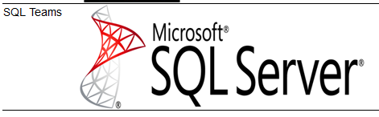

Creating your Database

The screen below allows you to create your database…
- The database name will be the P number of the student (database account holder) that sets up the database.
- Choose a password that is 8 characters or more and contains at least 1 number.
- DO NOT USE YOUR USUAL DMU LOG IN PASSWORD.
- Make a note of the password so you don’t forget it.
- Click ‘Create Database’ and share the log in details with the rest of your team members.
- If you forget your password once you’ve created your database you can revisit the tile and reset your password. Don’t forget to let your team members know the new password.
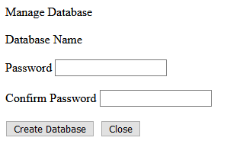

Page Updated 09/02/2023

Managing your Database
There are four different systems we need to configure in order to access your database, they are:
- The SQL Teams Portal – if you forget the password and need to change it
- Visual Studio – for creating and managing tables, stored procedures
- Data Connection Class – allowing your code to access the functionality provided by your stored procedures
- SQL Connect – a program to manage authentication of a secure connection

Accessing the Database in Visual Studio
For each team member to access the SQL Server database they will need the name of the server, username and password created above. (You should have made a note of this.)
In Visual Studio (VS) you will access your database via the SQL Server Object Explorer window (see below) which by default will be on the right-hand side of the interface.
If you can’t see it when you open VS go to View on the main menu and select it from the list displayed.
Next, we need to ‘Add SQL Server’ by clicking on the button...
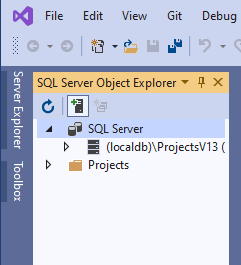

This will provide you with the following log in page:
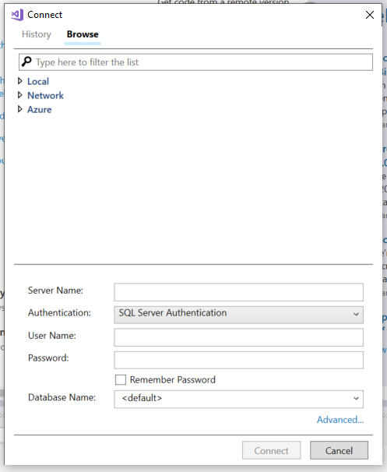
To connect to your database, complete the following fields and click the Connect button:
The Server Name is: v00egd00001l.lec-admin.dmu.ac.uk
Make sure that Authentication is set to SQL Server Authentication.
Username and Password are those created by the database account holder.

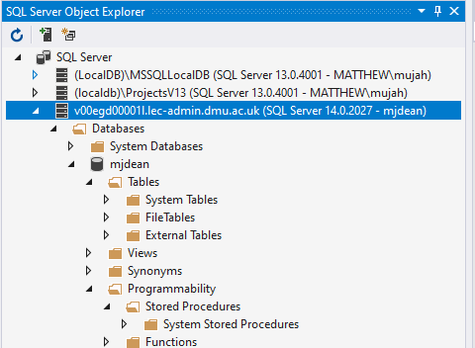
You should now be able to navigate the structure of the database.

At this stage expand the sections for “Tables” along with “Programmability > Stored Procedures”. These will be currently blank and will be populated with each team members tables and stored procedures as you work through the practical handouts.

Creating Tables
The next resource we need to create is a table to store some data in.
When you create your table it will be based on the table scheme you submitted in the system specification.
From the SQL Server Object Explorer, right click on the folder marked tables and select “Add New Table”. If you are using a local database, you will find your database in the ‘Server Explorer’.
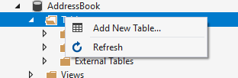
After a bit of waiting you will be presented with the following screen...
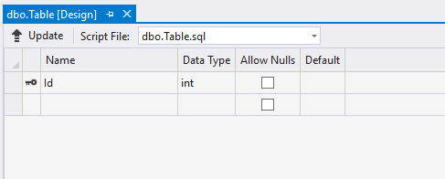
We will set up a basic table to store our addresses.
First, set the name of the table by modifying the SQL at the bottom of the window setting the table name to tblAddress...
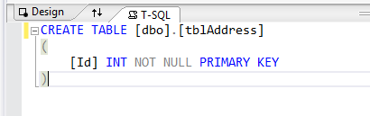
Note the “tbl” before Address: this is just to remind us that this is a table when writing select statements.

The next step is to create the fields for the table in the top section like so...
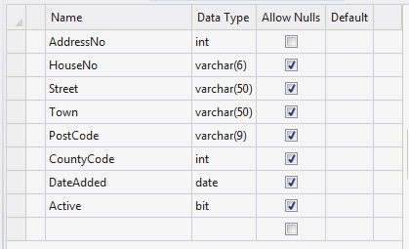
The column called ‘Name’ identifies the name of the data stored in the field (attribute). The column called ‘Data Type’ identifies what sort of data we are allowed to store in that field.
For example:

- Int - short for Integer meaning whole numbers. E.g. 1,2,3,-40, 100 NOT 4.5, 55.8 as these are decimal numbers.

- Varchar(6) - Any combination of letters or numbers up to 6 characters

- Date - Any valid data

- Bit - True or False only

When creating field names, it is always a good idea to consider the following:
- Avoid spaces AddressNo is better than Address No
- Avoid unusual characters # ~ !
- Use pascal naming convention AddressNo clearer than addressno
- Avoid certain reserved words date, password (+ others)

Assigning Primary Keys
Now that the fields have been set up, we need to do two more things.
The field AddressNo is going to be the primary key for this table and will be used to uniquely identify each record in the table.
The first step is to make sure this value is unique. To do this we set it as the identity of the table so that the database will generate this value.
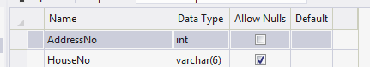
Click once in the name of the field to select it...

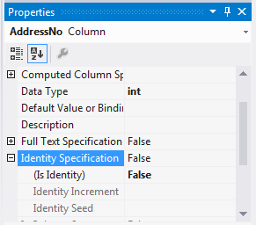

In the bottom, right hand corner of the program are the properties for the field.

Find the property called Identity Specification and expand it...
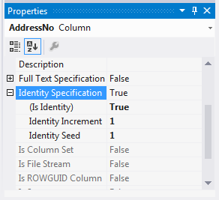

Change “Is Identity” from False to True like so...
This has set the field such it starts at 1 (identity seed) and for every new record the numeric value increases by 1 (identity increment).

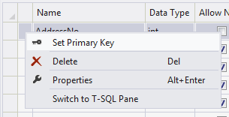
The last step is to set this field as the Primary Key for this table.
Right click to the left of the field name and select Set Primary Key...

The definition for the table should now look like this:
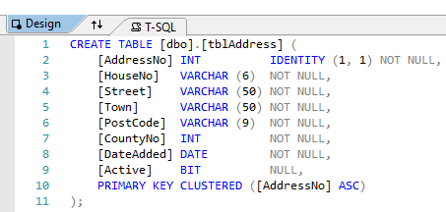

Now that the code to create the table is set up, we need to create the table.
In Visual Studio press the button that says Update:
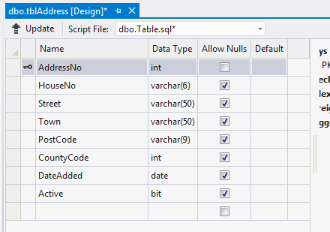
After a second or two the following screen should appear...
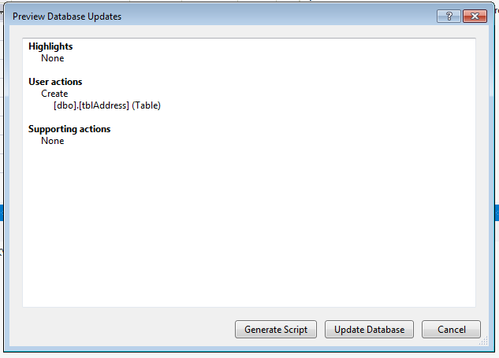
To create the new table, press Update Database.
If you get an error message or the Update Database button remains greyed out check you have completed the previous steps correctly and try again.
Note: if you don’t update the database and you open your database at a later date your table or any changes you made will be lost and you’ll have to add the new table again. Always update the database when making changes or adding new tables or stored procedures.
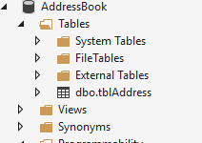
Your table should now be visible.

If it doesn’t appear right click on the Tables folder and select Refresh.

Adding Data to the Table
The next step is to add some data to your table to make sure it is working.
In the Server Explorer right click on the name of the table and select ‘Show Table Data’.
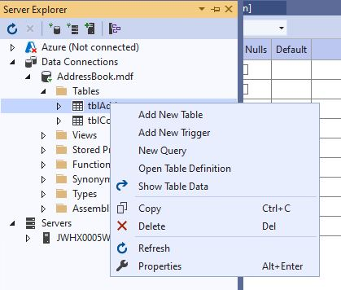
This will give you a screen allowing you to add new data to the table. Add data for each field and press the enter key on the once you’ve added data to the last field.
Notice as you add the data the value for the AddressNo field is updated automatically by the database...
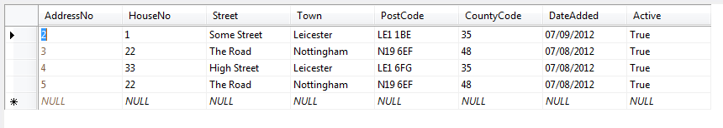
Add a few records so that we have some data for the next stage of the work.

Creating Stored Procedures
We will not be accessing the table directly with our code but using a stored procedure. One of the biggest advantages of this approach is that of increased security.
Creating a stored procedure is a very similar process to creating a table.
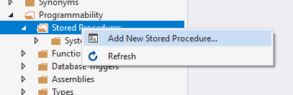
Right click on the ‘Stored Procedure’ folder and select “Add New Stored Procedure...”

After a little while you should see the following screen appear...
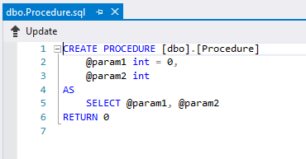
Modify the SQL code as follows...
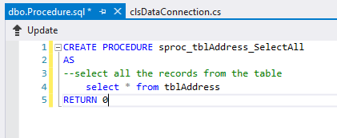
As in the case of adding the table you must press ‘Update’ to make the changes to the database structure.
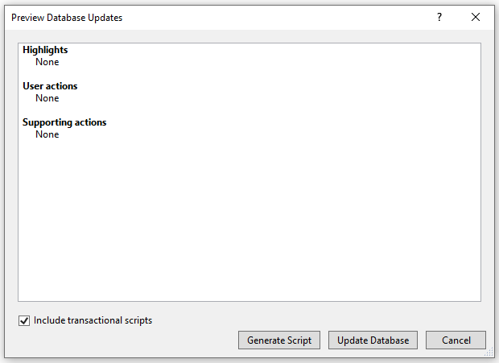

You should see the stored procedure in the tree structure of the database, if not try refreshing it...
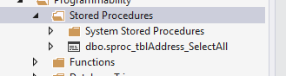

Testing the Stored Procedure
To make sure the stored procedure is working right click on it like so and select ‘Execute Procedure…’
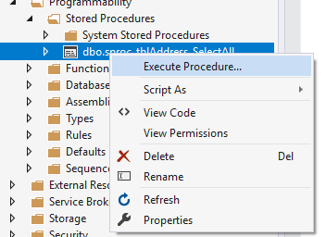
You should see the data from the underlying table displayed.
Close the query output window without saving it.
If you don’t see any data, revisit and check the stored procedure and execute it again.

Setting up a Local Database
One of the issues with having SQL Server running solely on the DMU network is that you must access your work via Your DMU Labs. For the most part this is fine but it may be inconvenient if you do not have a great internet connection.
A work around for this is to set up a local database which has the following advantages and disadvantages.
Disadvantages
- You cannot share the database with your team members
- GitHub won’t respond well if you try to share it that way
- If you want to set up tables and stored procedures in your shared SQL Server database, you will have to duplicate the work
Advantages
- It doesn’t require an internet connection
- It is really simple to set up

Creating the Folder Structure for your Database
To create the local database file, you need to create a folder that is not part of your Skeleton System project folder structure.
It doesn’t matter where you create your database, but it needs to be separate from any code going through GitHub.
Create your folder (with an informative name) and make a note of where it is for future reference. Your H:drive would be the most sensible place.
Once you have created a folder open your project in Visual Studio.

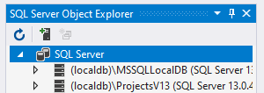
If you have created an SQL Server account you have most likely been using the SQL Server Object Explorer.

For this configuration you will be using a similar tool instead, the ‘Server Explorer’…
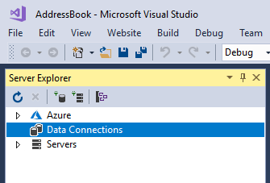
If you cannot see it go to View on the main menu and select ‘Server Explorer’ from the list to make it visible…
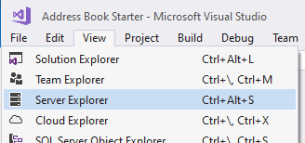

Click on the button ‘Connect to Database’.
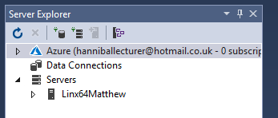

And you should see the following dialogue box.
Select “Microsoft SQL Server Database File and press OK.
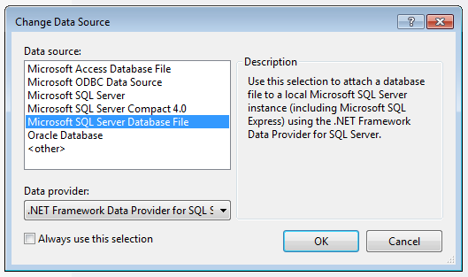

You should next see the following screen... Click on the ‘Browse’ button…
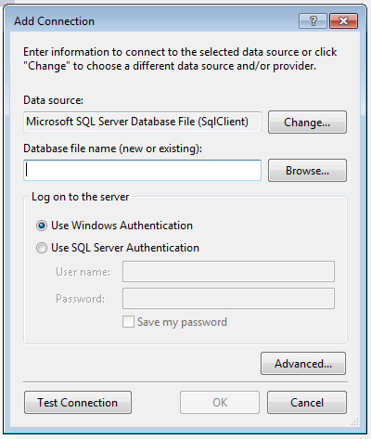
…and navigate to the folder you created earlier.
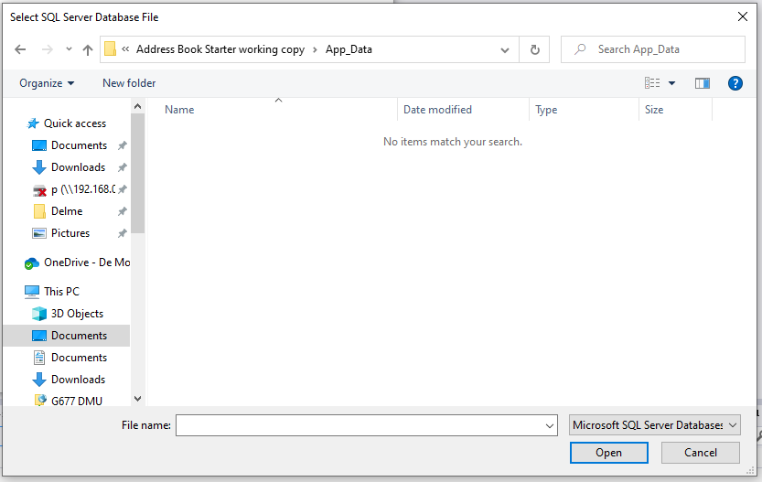

In the File Name text box type the name of the database file you want to create, in my case AddressBook.mdf and then click the ‘Open’ button.
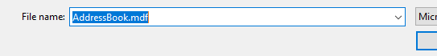

On the next screen press OK
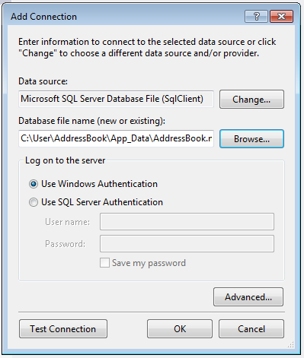

Visual Studio should now ask if you want to create the database file. Click ‘Yes’.
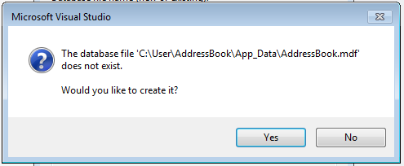

You should now be able to access it via the Server Explorer on the left of the program...
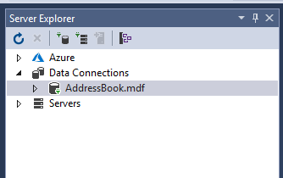

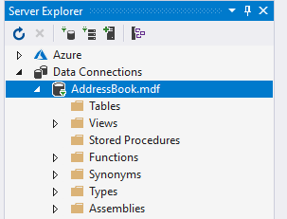
The interface for the Server Explorer is very similar to the Server Object Explorer.

At this stage expand the sections for “Tables” along with “Stored Procedures”. These will be currently blank and will be populated with your own tables and stored procedures as you work through the practical handouts.
Remember that this is a local install of the database so any data will not be shared with other team members.

Before you can add tables and stored procedures, we need to generate the Connection String

Generating the Connection String
Now that the folder and local database are created download the ‘SQL Connect’ executable file from the website. Ignore any warning messages.
We need to tell SQL Connect the location of the database file so that it can generate the connection string.

Open SQL Connect and you should see something like this:
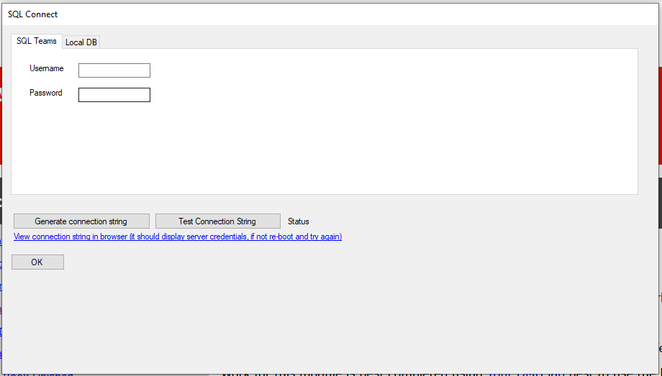
Select the tab ‘Local DB’…
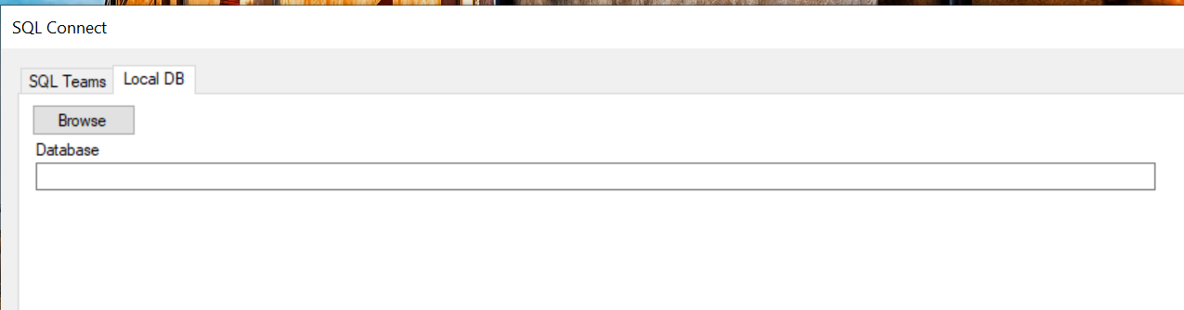
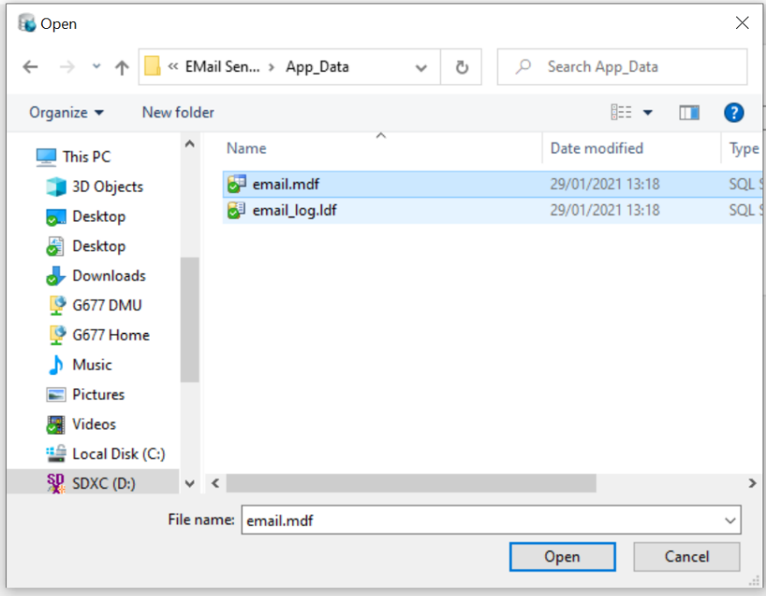

Press browse and navigate to the location of your database file and select the .mdf file then click the Open button.

The file path should be listed like so…
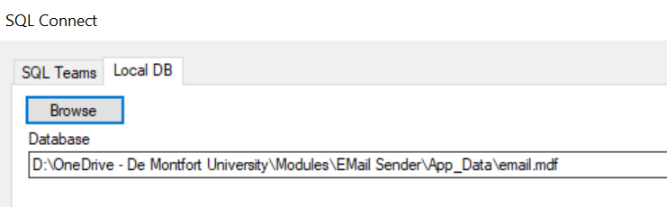

Next press generate connection string…
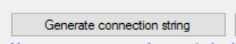

Then press test connection string…
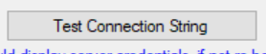

If all is OK you see the folowing message…
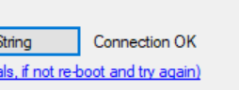
If there are issues you may check the connection string by pressing the link…

You will now be able to create your tables and stored procedures by following the instructions from page 5.

